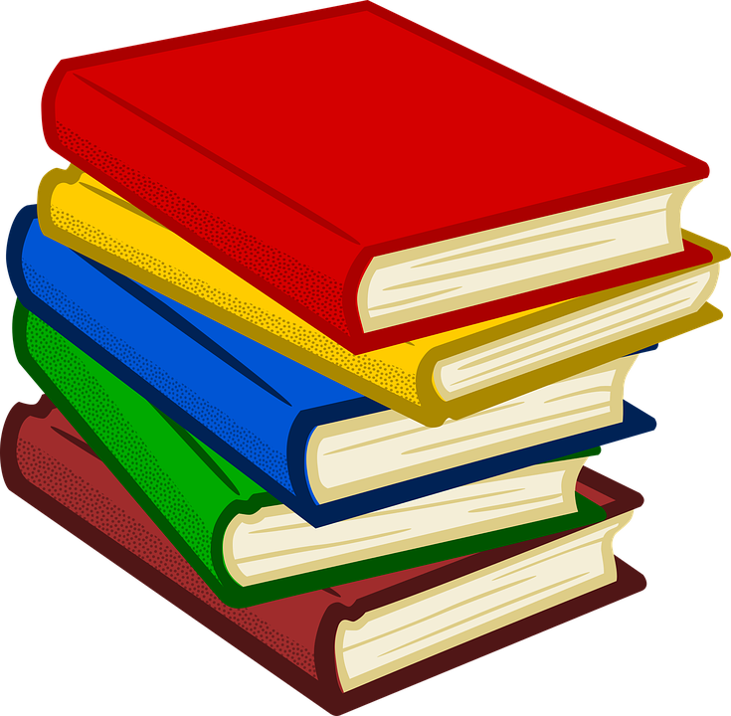
Did you know you can check out eBooks from Dr. Phillips Elementary Media Center?

Here’s how…

On your device (computer, tablet, or phone)
- Log into Launch Pad (launch.ocps.net)
- Open Follett Destiny (District)
- Click on “See All” to display the available eBooks
- Scroll down to view the titles and click on the Check Out button
- Click the Open button to begin reading

To see what books and eBooks you have checked out, click the three bars in the upper left corner on the Destiny Discover home page. From the drop down menu click checkouts and from there you can open any of your eBooks.

You can check out eBooks from
Orange County Library too!

Computer:
- Log into Launch Pad (launch.ocps.net)
- Open Library Research Tools
- Open Virtual Library Card and log in using student number and password
- Click on Enjoy a Selection of E-Books
- From the drop down menu select OverDrive Kids Collection
- Search for the title you are interested in then click on BORROW
- Select Read Now in Browser
To see what eBooks you have checked out click on My Account

Tablet or Phone
- In the App store download Launchpad (school district: OCPS)
- Open Library Research Tools
- Open Virtual Library Card
- Click on Enjoy a Selection of E-Books
- From the drop down menu select OverDrive Kids Collection
- Search for the title you are interested in then click on BORROW
- Select how you would like to download the book
To see what books and eBooks you have checked out, click the three bars in the upper right corner. From the drop down menu click My account then loans.

To check if a title is an AR book go to http://www.arbookfind.com/default.aspx.

